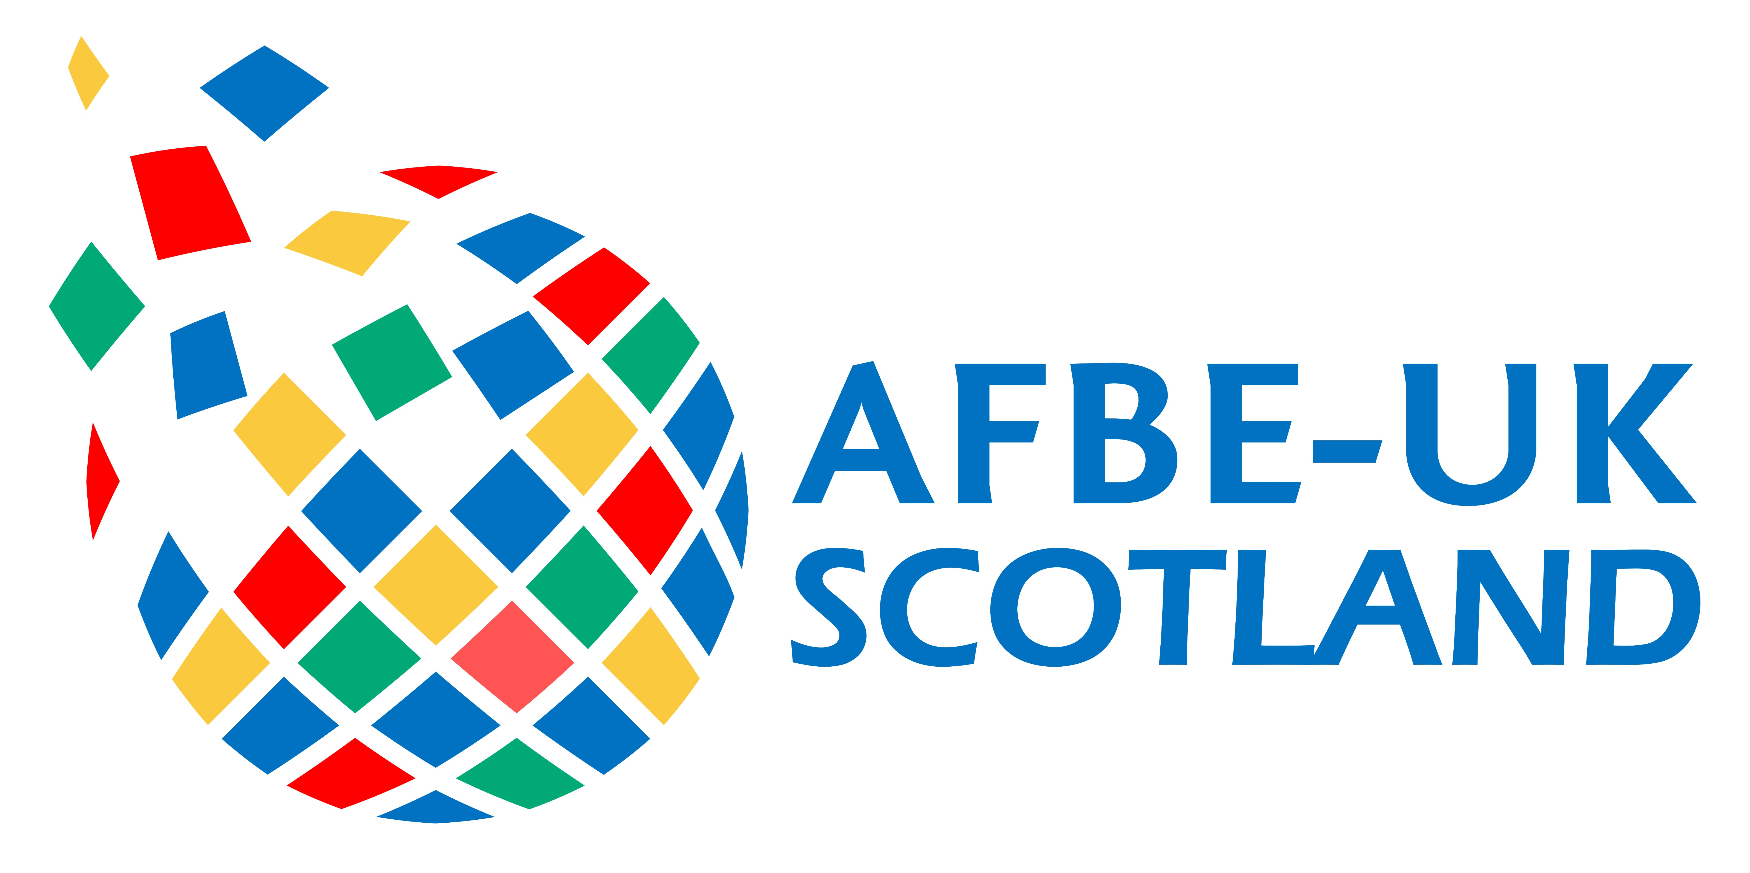
AFBE-UK Scotland Awards 2018

YOUNG BME PROFESSIONAL AWARD

This Award is run by the AFBE-UK Scotland with the expressive purpose of encouraging and recognising an outstanding young engineer from the BME community.

This engineer should be nominated by his/her company. This nomination should be an acknowledgement of this member’s impact on the company’s results.

This award is proudly sponsored by The Society of Petroleum Engineers (SPE)

Award’s eligibility criteria are as follows:
- Engineer from BME origins employed in any field
- Holds Bachelor and/or Master’s degree in engineering or a related field
- Under 10 years post-graduation experience with outstanding contribution to current team’s objectives
- Age limit 35 years

Nominating company

Company name
Address
Town
County
Postcode

Nominee

Title
Name
Job title
Department
Phone no.
Mobile no.
Email

MOTIVATION

- Tell us a little about yourself.

Word limit: 100 words. Please use the space provided. Do not attach additional sheets.

HINT:

Where did you to University?
What’s your highest academic qualification to date?
Are you chartered?
Did you graduate with an honours degree
What do you do now and for what company?
How long have you worked for your current employer?

- Using examples of projects tell us your biggest achievement at work so far.

Word limit: 200 words. Please use the space provided. Do not attach additional sheets.

HINT:

What projects have you (or your nominee worked on) undertaken that received commendation from the employer or client?

What actions taken on your (or your nominee’s) initiative has resulted in any of the following:

- An innovative approach to problem solving.
- Safety of personnel.
- Less environmental impact.
- Improved operability.
- Cost savings.
- Energy efficiency.

Have you or your nominee won any awards for your work?

Be clear about your (or your nominee’s) role in achieving any of the above

- Do you have any additional information that may help your application

Word limit: 200 words. Please use the space provided. Do not attach additional sheets.

HINT:

- Information about STEM outreach in schools or community programme.
- Any evidence of fund raising for charitable causes.
- Evidence of continuous professional development.
- Evidence of other part-time initiatives e.g. businesses etc.

ADDITIONAL INFORMATION

Can a current or former supervisor vouch for yours (or your nominee’s) character and performance?
Word limit: 250 words. Please use the space provided. Do not attach additional sheets.

Pictures

You may upload up to 2 photos/images to support your entry. Acceptable formats are JPG, GIF or BMP. Please ensure all items are embedded in the form; attachments will be deleted unread.

Picture 1

Picture 2

Please send your completed form to:

info@afbescotland.org

This form can be filled in by a third party on the nominee’s behalf

