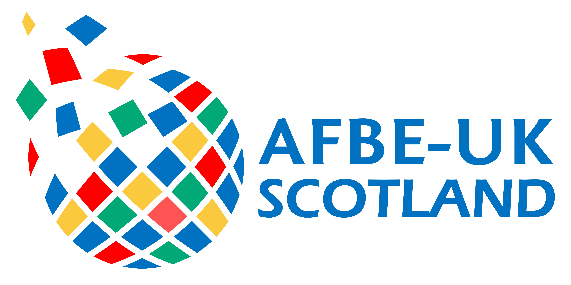

AFBE-UK Scotland Awards 2018

OUTSTANDING MENTOR AWARD

This Award is run by the AFBE-UK Scotland with the purpose of recognising an individual involved in mentoring others in addition to their regular job. Nominations can be made by or on behalf of an individual. This nomination should be an acknowledgement of this individual’s effort to help others succeed as STEM Professionals.

This award is proudly sponsored by Energy Institute

Criteria

The winner of this award may be someone that:

- facilitates the acquisition of skills and resources.
- provides support through published material and/or work placements for young people.
- demonstrates concern and support of the personal development of students.
- Is a successful role model.
- Has a long term commitment to mentoring.

Nominee

Name
Address
Town
County
Postcode

Nominator

Title
Name
Job title
Department
Phone no.
Mobile no.
Email
MENTORSHIP

Based on the criteria above tell us why you or your nominee deserves this award. (Examples of work done to facilitate the acquisition of skills, assistance towards the chartership etc.)

Word limit: 500 words. Please use the space provided. Do not attach additional sheets.

ROLE MODEL

Tell us about yours (or your nominee’s) career progression and achievements and why you think yours (or your nominee’s) career should be a source of inspiration for young professionals.

Word limit: 500 words. Please use the space provided. Do not attach additional sheets.

Pictures

You may upload up to 2 photos/images to support your entry. Acceptable formats are JPG, GIF or BMP. Please ensure all items are embedded in the form; attachments will be deleted unread.

Picture 1

Picture 2

